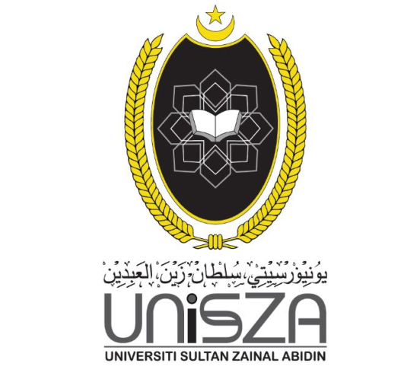

NAMA: BALAVIDHINI A/P MANIMARAN

NOMBOR MATRIK: 065650

NAMA PENSYARAH: MAT ATAR BIN MAT AMIR

UNIVERSITI SULTAN ZAINAL ABIDIN

FAKULITI INFORMATIK DAN KOMPUTERAN

IJAZAH SARJANA MUDA TEKNOLOGI MAKLUMAT

(INFORMATIK MEDIA)

ITM 13103: ART & DESIGN

LAPORAN: “INDIVIDUAL PROJECT”

(COPORATE IDENTITY)

**RESEARCH**

[**https://flyclipart.com/thumb2/caps-images-color-pages-baseball-cap-line-art-316563.png**](https://flyclipart.com/thumb2/caps-images-color-pages-baseball-cap-line-art-316563.png)

[**https://www.pngitem.com/pimgs/m/45-457900_baseball-hat-baseball-cap-clipart-transparent-background-cap.png**](https://www.pngitem.com/pimgs/m/45-457900_baseball-hat-baseball-cap-clipart-transparent-background-cap.png)

[**https://thumbs.dreamstime.com/z/air-travel-illustration-airplane-brochure-tourism-theme-business-agency-advertisement-poster-design-vector-eps-169381425.jpg**](https://thumbs.dreamstime.com/z/air-travel-illustration-airplane-brochure-tourism-theme-business-agency-advertisement-poster-design-vector-eps-169381425.jpg)

[**https://encrypted-tbn0.gstatic.com/images?q=tbn:ANd9GcQrjKAm5Y91zq_kg2rXPT7u30hefNd9BI0Ibw&usqp=CAU**](https://encrypted-tbn0.gstatic.com/images?q=tbn:ANd9GcQrjKAm5Y91zq_kg2rXPT7u30hefNd9BI0Ibw&usqp=CAU)

[**https://media.istockphoto.com/vectors/modern-creative-business-card-template-visiting-card-set-with-for-vector-id1243495587?b=1&k=20&m=1243495587&s=612x612&w=0&h=d9IUmLZkLdqEhKpm1Hi0aAjp6a8EGzwbNC_o8suEiW8=**](https://media.istockphoto.com/vectors/modern-creative-business-card-template-visiting-card-set-with-for-vector-id1243495587?b=1&k=20&m=1243495587&s=612x612&w=0&h=d9IUmLZkLdqEhKpm1Hi0aAjp6a8EGzwbNC_o8suEiW8=)

[**https://img.favpng.com/19/22/7/t-shirt-sleeve-sports-fan-jersey-clothing-polo-shirt-png-favpng-0xa5savFgSVN0bupJXcmLkycs.jpg**](https://img.favpng.com/19/22/7/t-shirt-sleeve-sports-fan-jersey-clothing-polo-shirt-png-favpng-0xa5savFgSVN0bupJXcmLkycs.jpg)

[**https://d1csarkz8obe9u.cloudfront.net/posterpreviews/travel-%26-tourism-logo-design-template-fa5221627425b34cf99d9ed1775a537a_screen.jpg?ts=1619012323**](https://d1csarkz8obe9u.cloudfront.net/posterpreviews/travel-%26-tourism-logo-design-template-fa5221627425b34cf99d9ed1775a537a_screen.jpg?ts=1619012323)

[**https://previews.123rf.com/images/andyadi/andyadi1802/andyadi180200442/94972368-vector-logo-design-of-ocean-sea-water-beach-summer-sailing-tourism-for-travel-tour-yacht-hotel-ship-.jpg**](https://previews.123rf.com/images/andyadi/andyadi1802/andyadi180200442/94972368-vector-logo-design-of-ocean-sea-water-beach-summer-sailing-tourism-for-travel-tour-yacht-hotel-ship-.jpg)

[**https://illustoon.com/photo/4162.png**](https://illustoon.com/photo/4162.png)

[**https://encrypted-tbn0.gstatic.com/images?q=tbn:ANd9GcQeqWoirKaitjvWv4wiR0HaEwCRcUXl2kneig&usqp=CAU**](https://encrypted-tbn0.gstatic.com/images?q=tbn:ANd9GcQeqWoirKaitjvWv4wiR0HaEwCRcUXl2kneig&usqp=CAU)

**IDEA / CONSEPT**

Corporate identity is important for companies to expose their business nature to the public. For individual project, we are allowed to choose and create any logo based on given theme which is Tourism Industries. We also need to create a corporate identity design for the themes such that printed and digital design. Therefore, I was chosen airline service as a corporate company. Air transport is the main mode of international tourism. Air transport plays a dominant role in inter-regional movements of tourists, which normally entails travel over long-distance. Growth rates of international air traffic are pegged with growth rates of international tourism. Attractive package tours, competitive airfare attract more and more tourist’s day by day, therefore the industry is expanding rapidly.

* **T-shirt and Cap**

Clothes and hats have been selected in this assignment as printed corporate identity. The colors found in the two products are the result of a combination and processing of colors found in the company logo. The colours of t-shirt is yellow, sky blue, grey with the logo of our Sky Tour Company. Our company cap in yellow, red, black and also with logo. The tourist who buys and wearing our cap and t-shirt will feel perfect match between these two items.

T-shirt ideas:

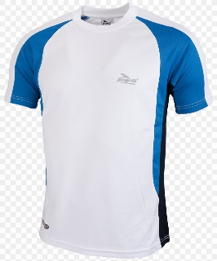 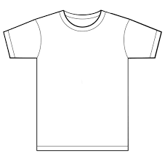 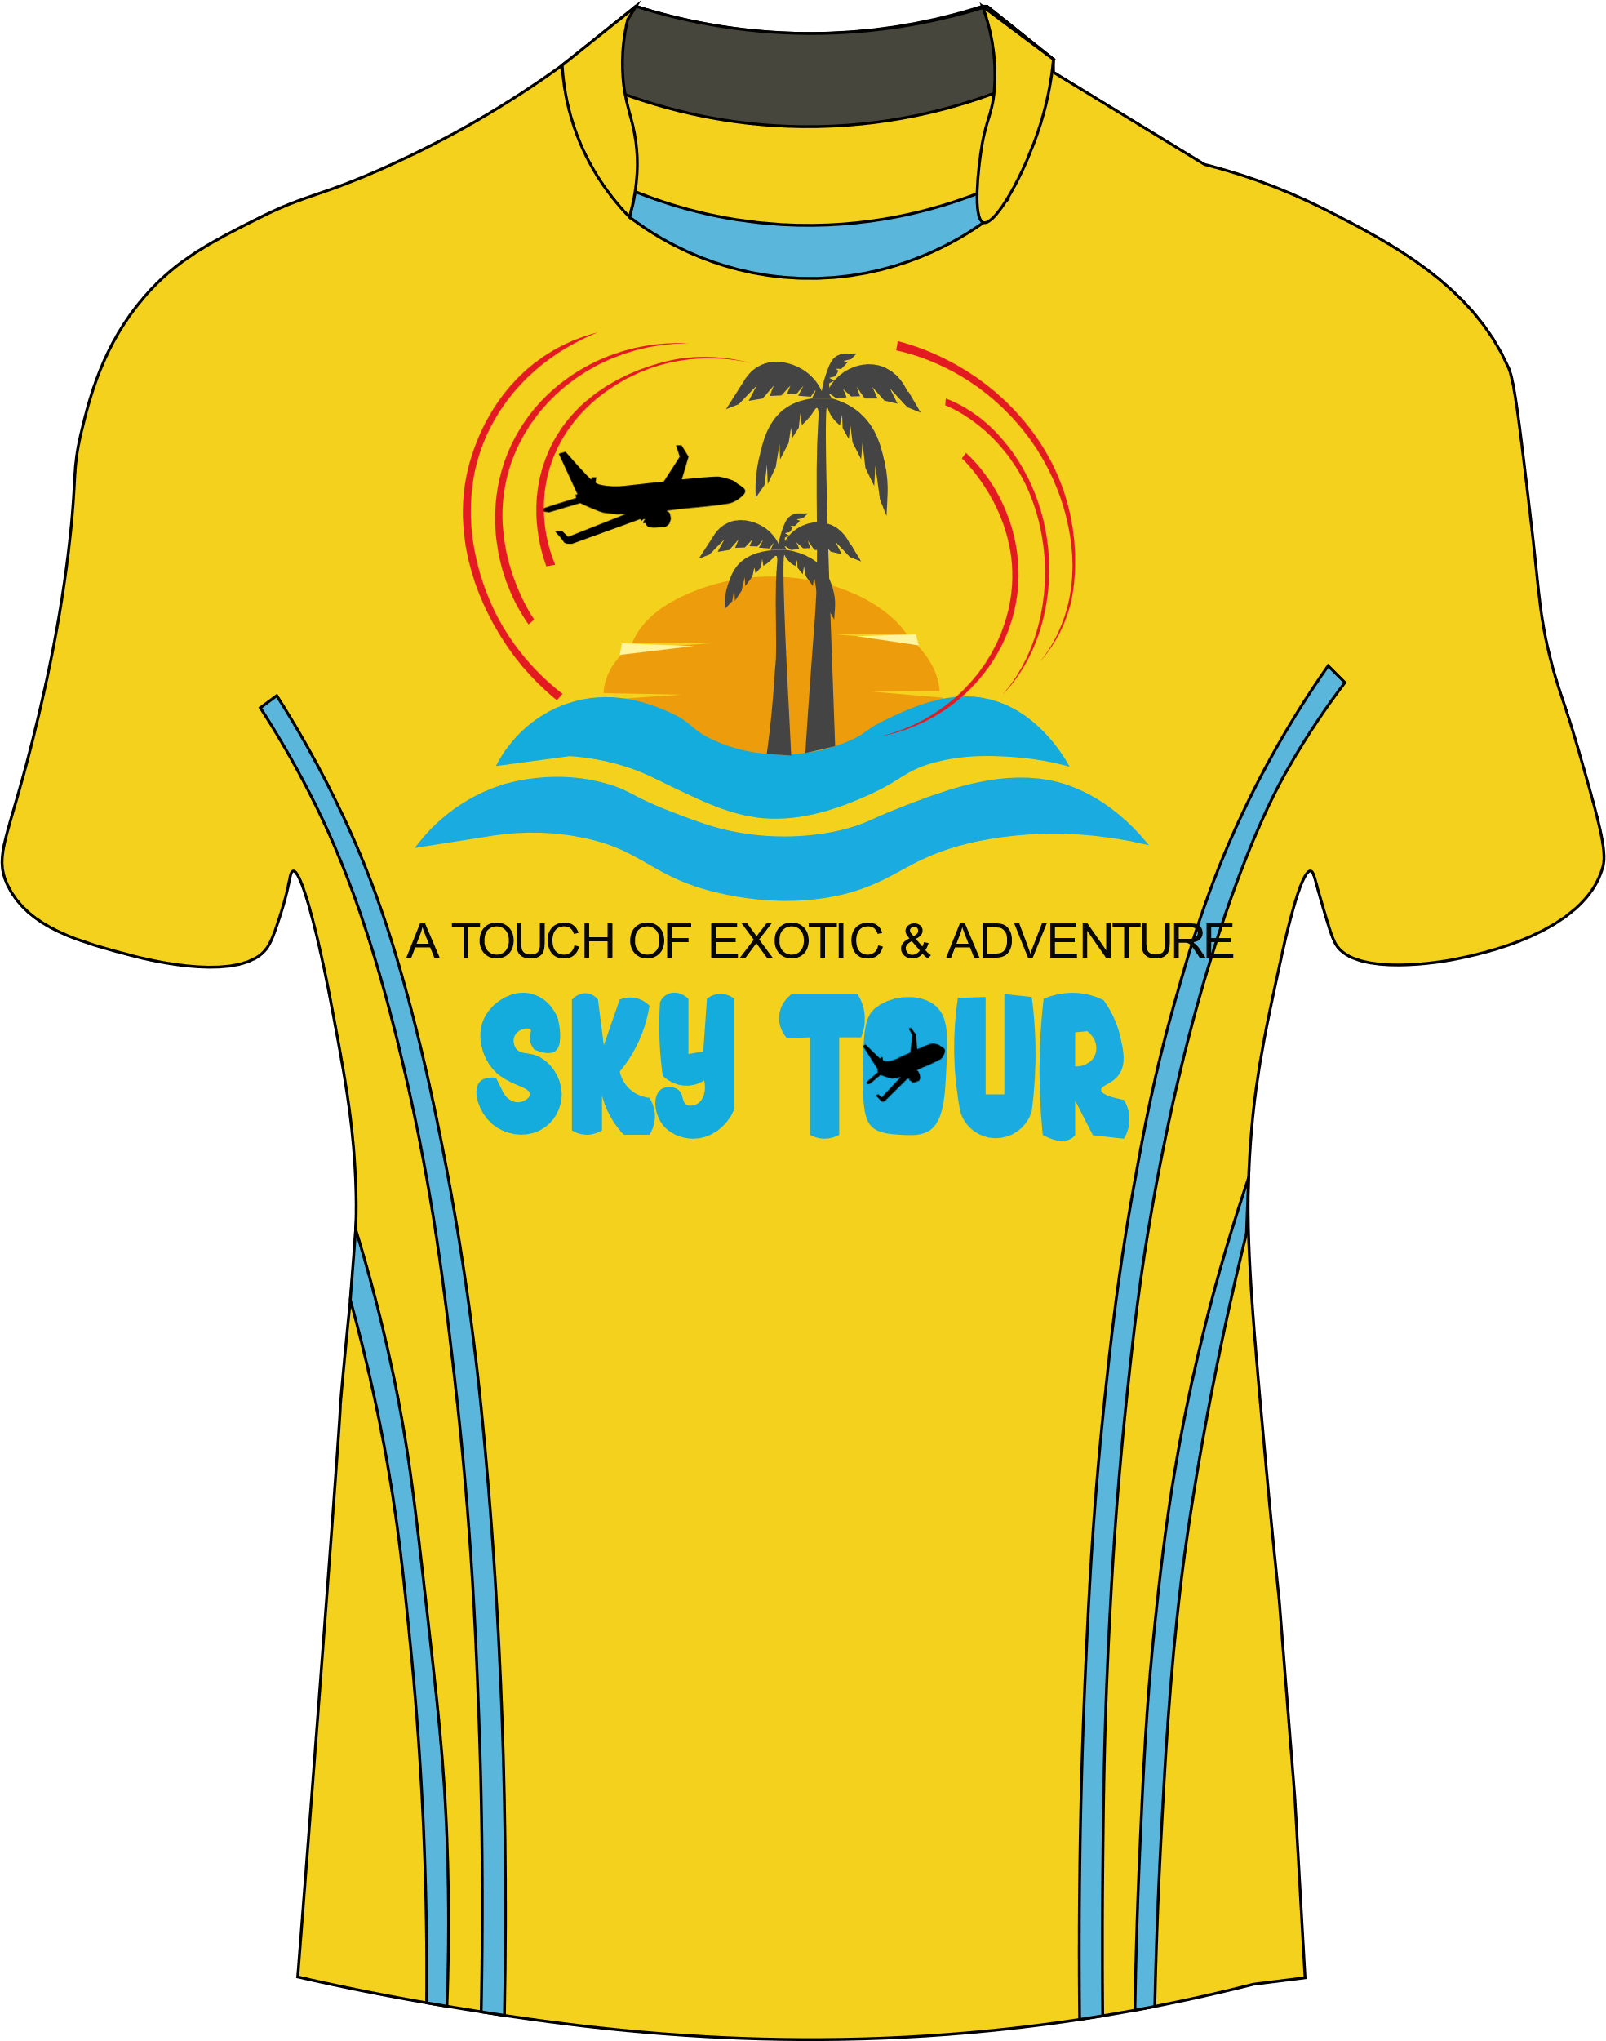

Cap ideas :

  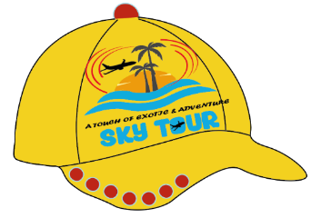

* **Business card and Poster**

Business and poster have been selected as the next product to attract tourists to meet the needs of the question that wants 2 digital designs. Business card is in grey and yellow colour with company details. Yellow and grey colour in business card represents company logo colour. While the poster mainly focusing on sky blue and dark blue, white colour which is represent the sea, sky and the flight.

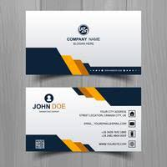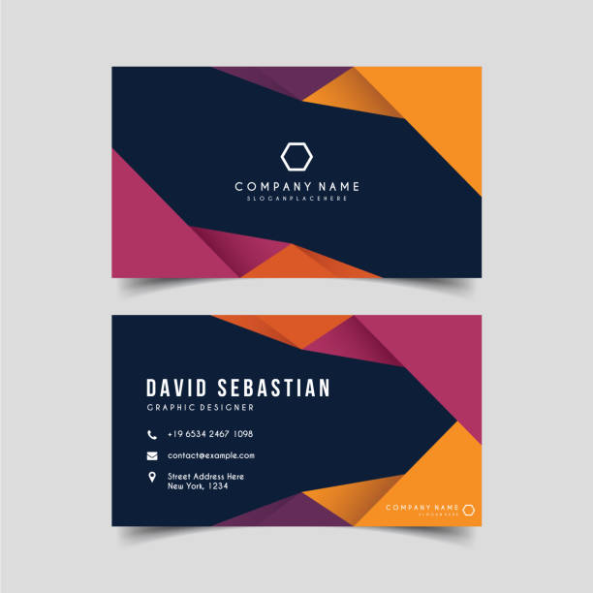

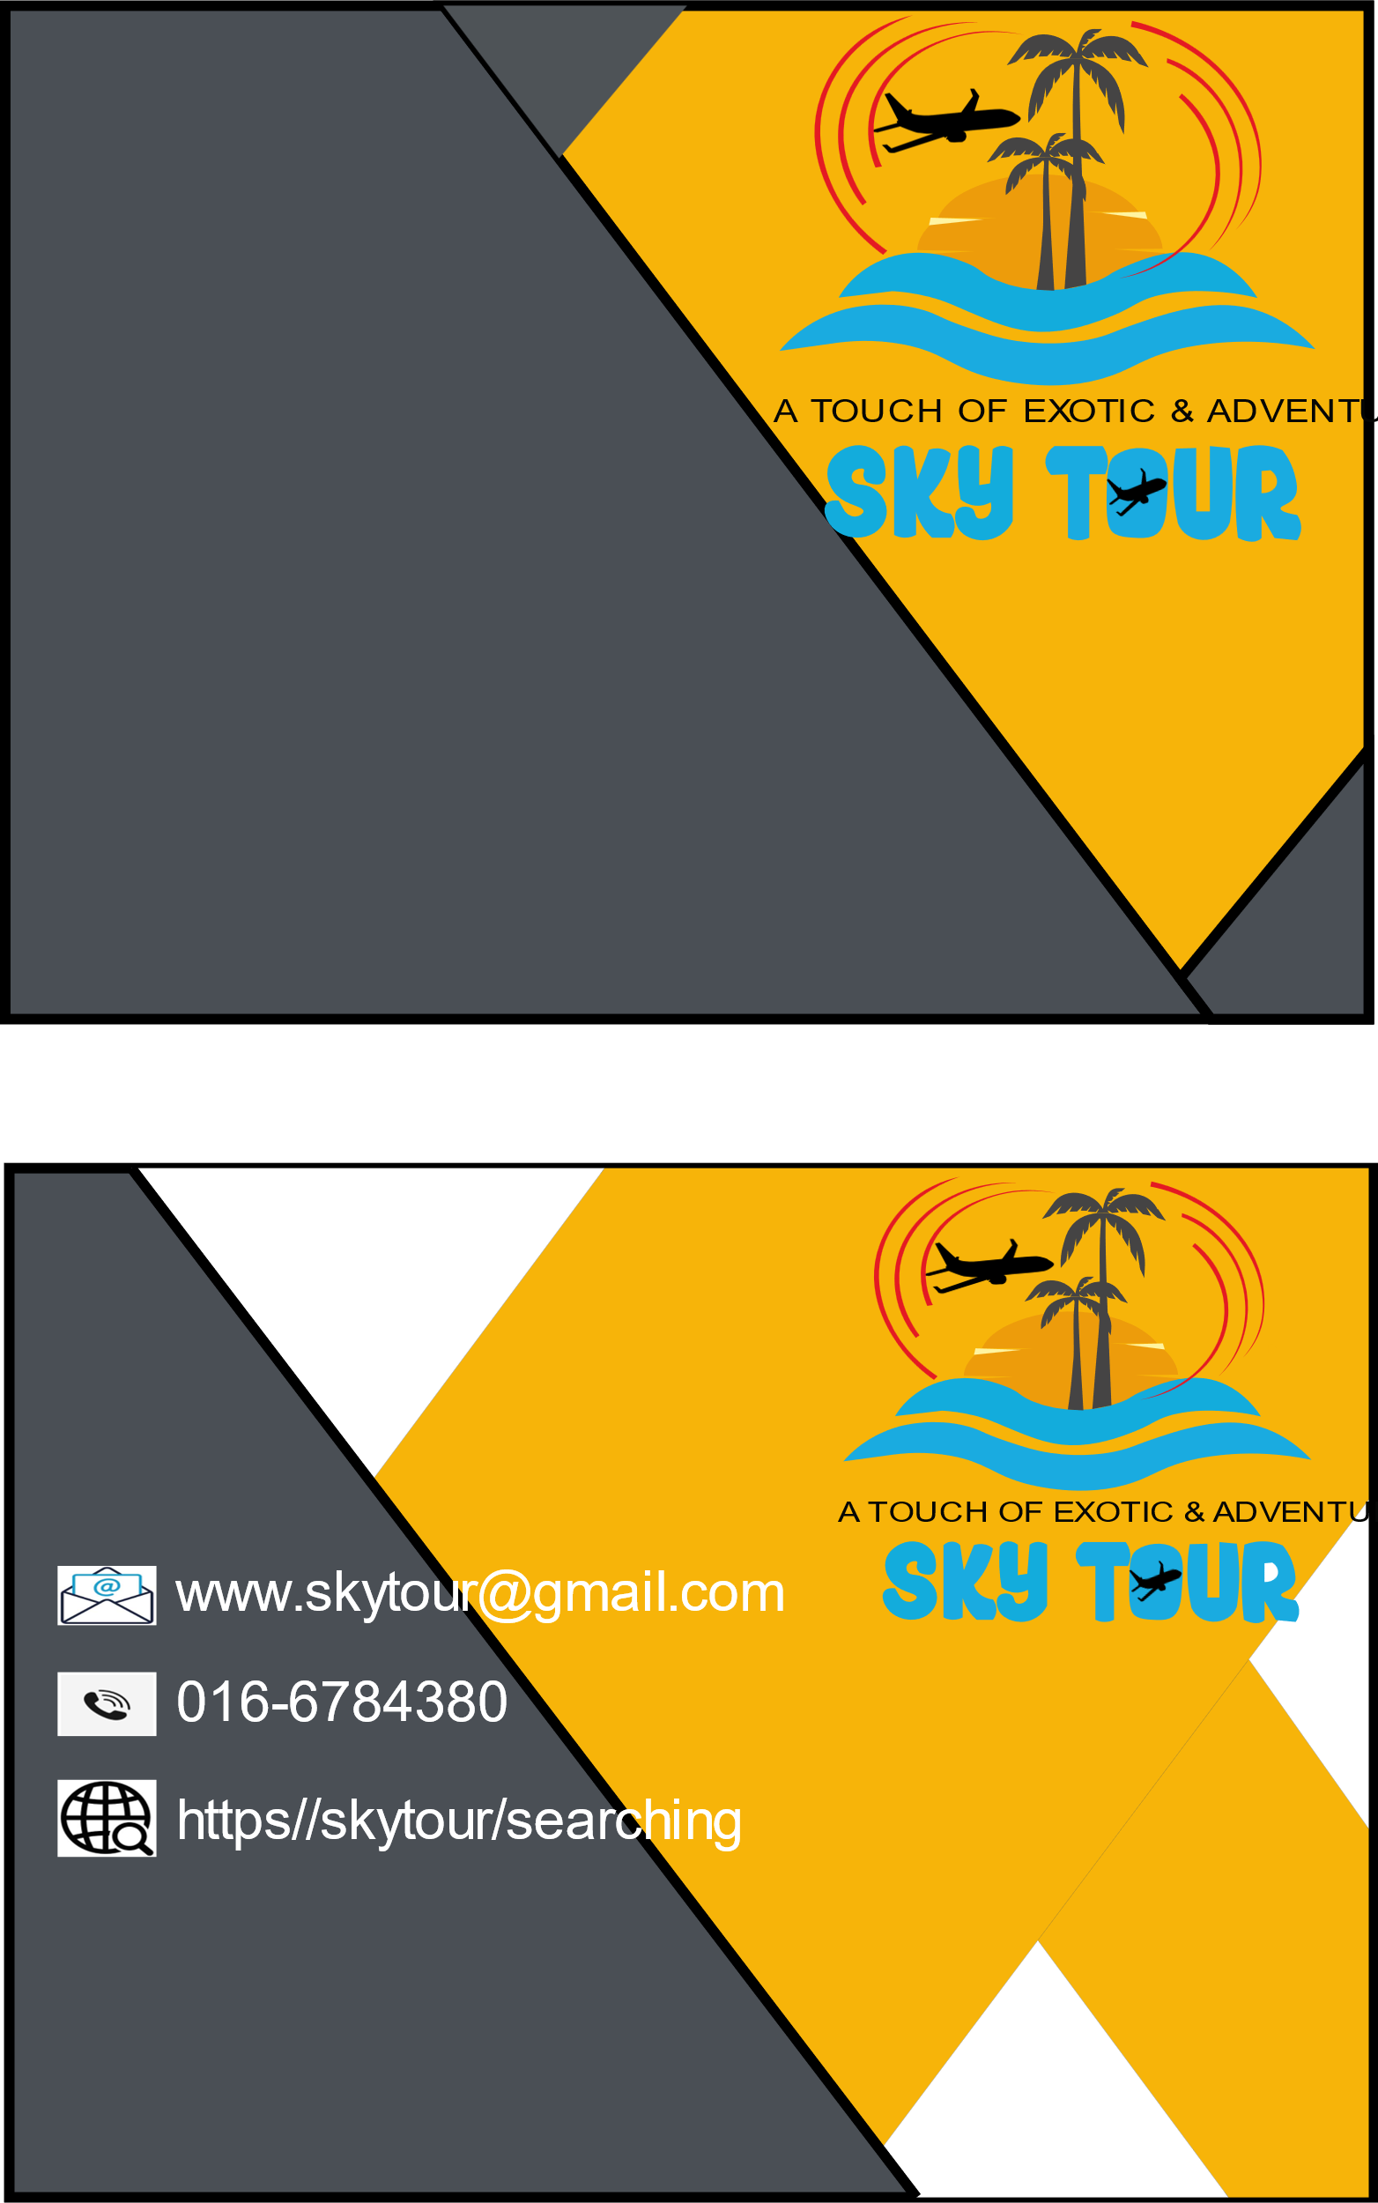

**Combination of ideas**

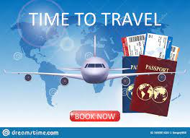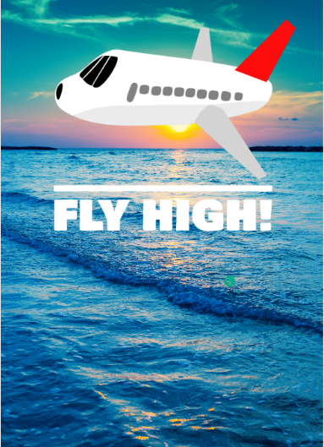

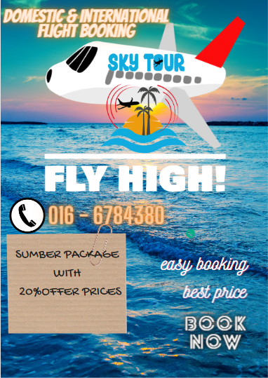

**Combination of ideas**

* **Logo**

The logo of Sky Tour created for a reason, not simply created. Every element in the logo represents something which is related to traveling of tourism industry. Let’s see it:

1. Flight - Air travel is the fastest method of transport around, and can cut hours or days off of a trip. Everyone can travel to new countries to meet up with new peoples, cultures, and beautiful places.
2. Sea – it’s representing the world is full of water such that beaches. Everybody can cross the sea to take a look at other countries with our help of Sky Tour company.
3. Trees and sun – the tree and sun show summer time which is suitable for goes for a trip
4. Sky Tour letter – Sky is the region of the atmosphere and outer space seen from the earth while tour is a journey for pleasure in which several different places are visited.

Logo ideas get from several images which is listened below:

**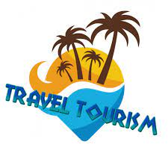****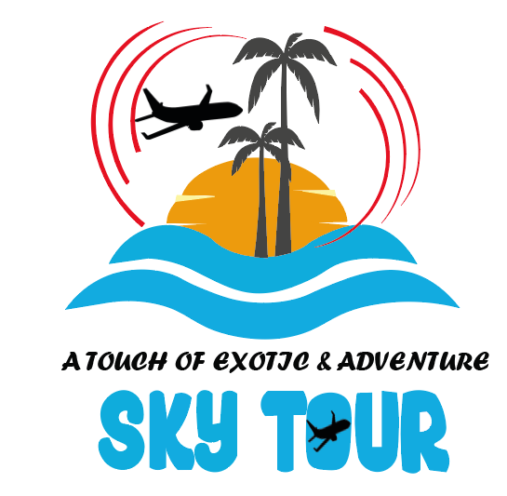**

**Logo Created**

**Combination of ideas**

**SKETCHING / STORYBOARD**

**LOGO**

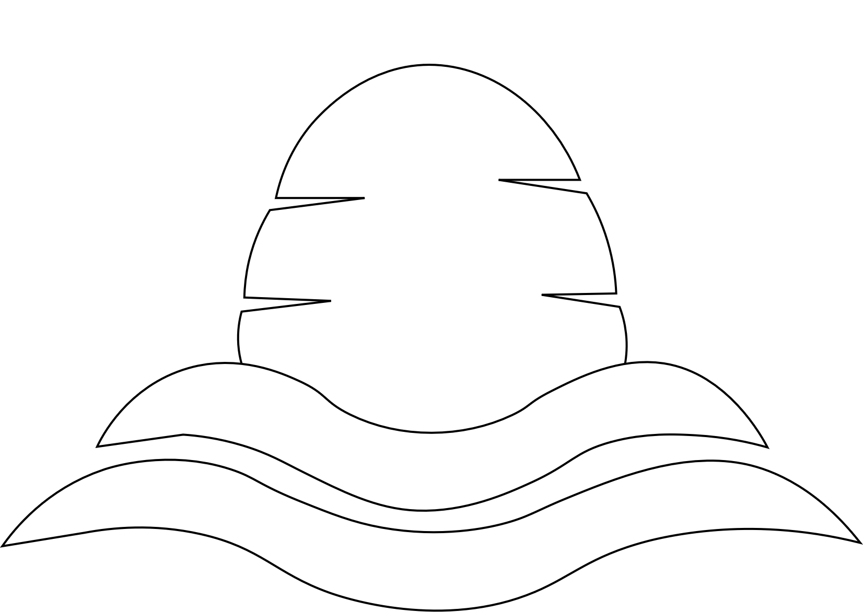 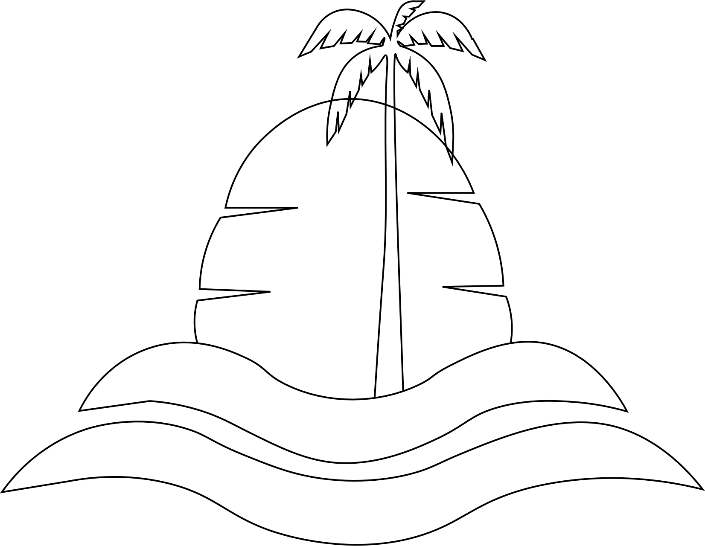 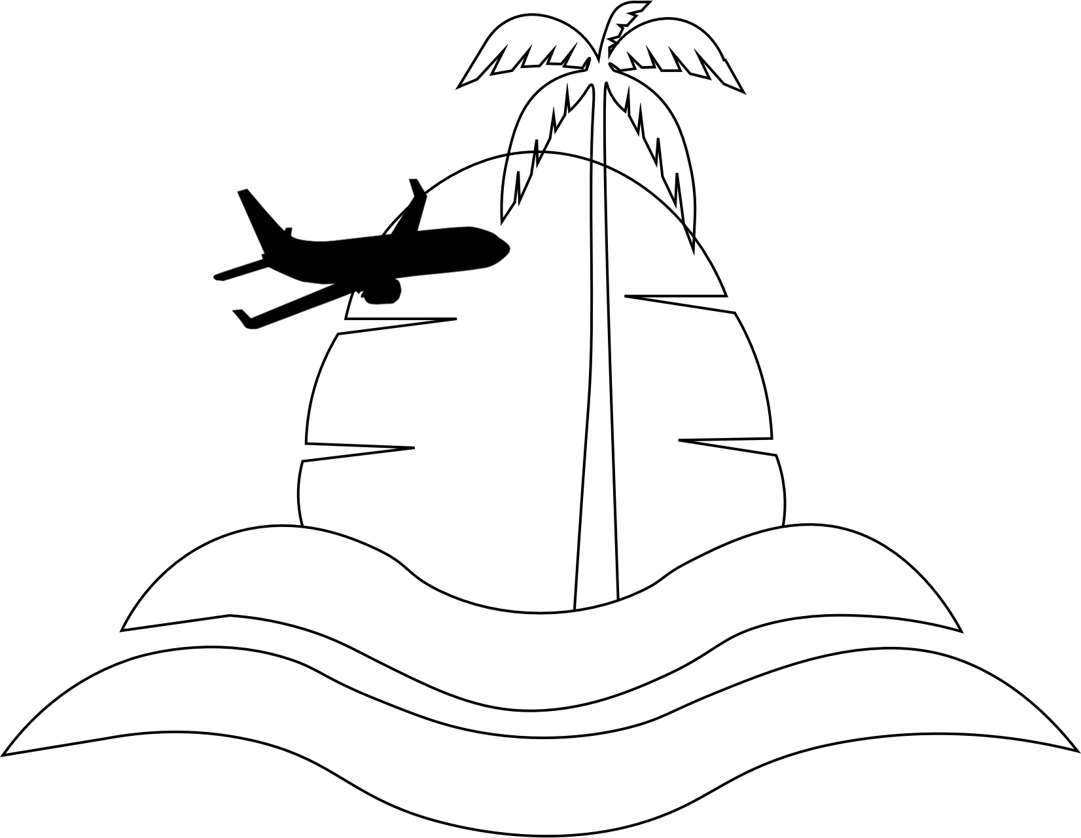

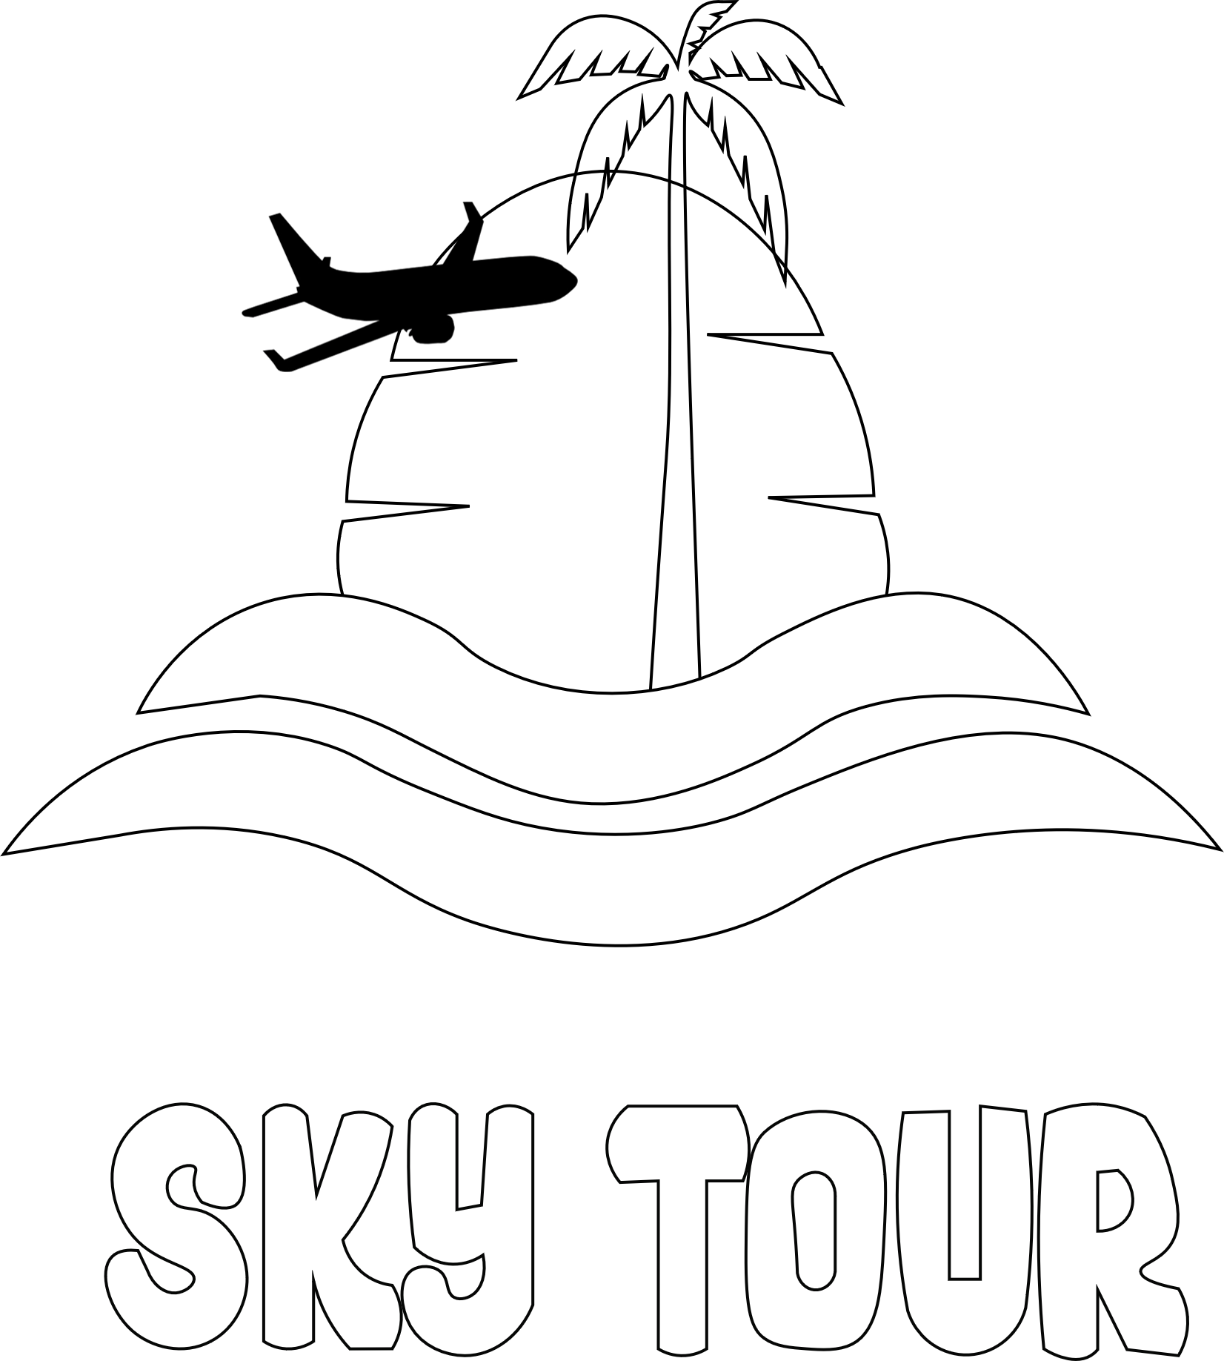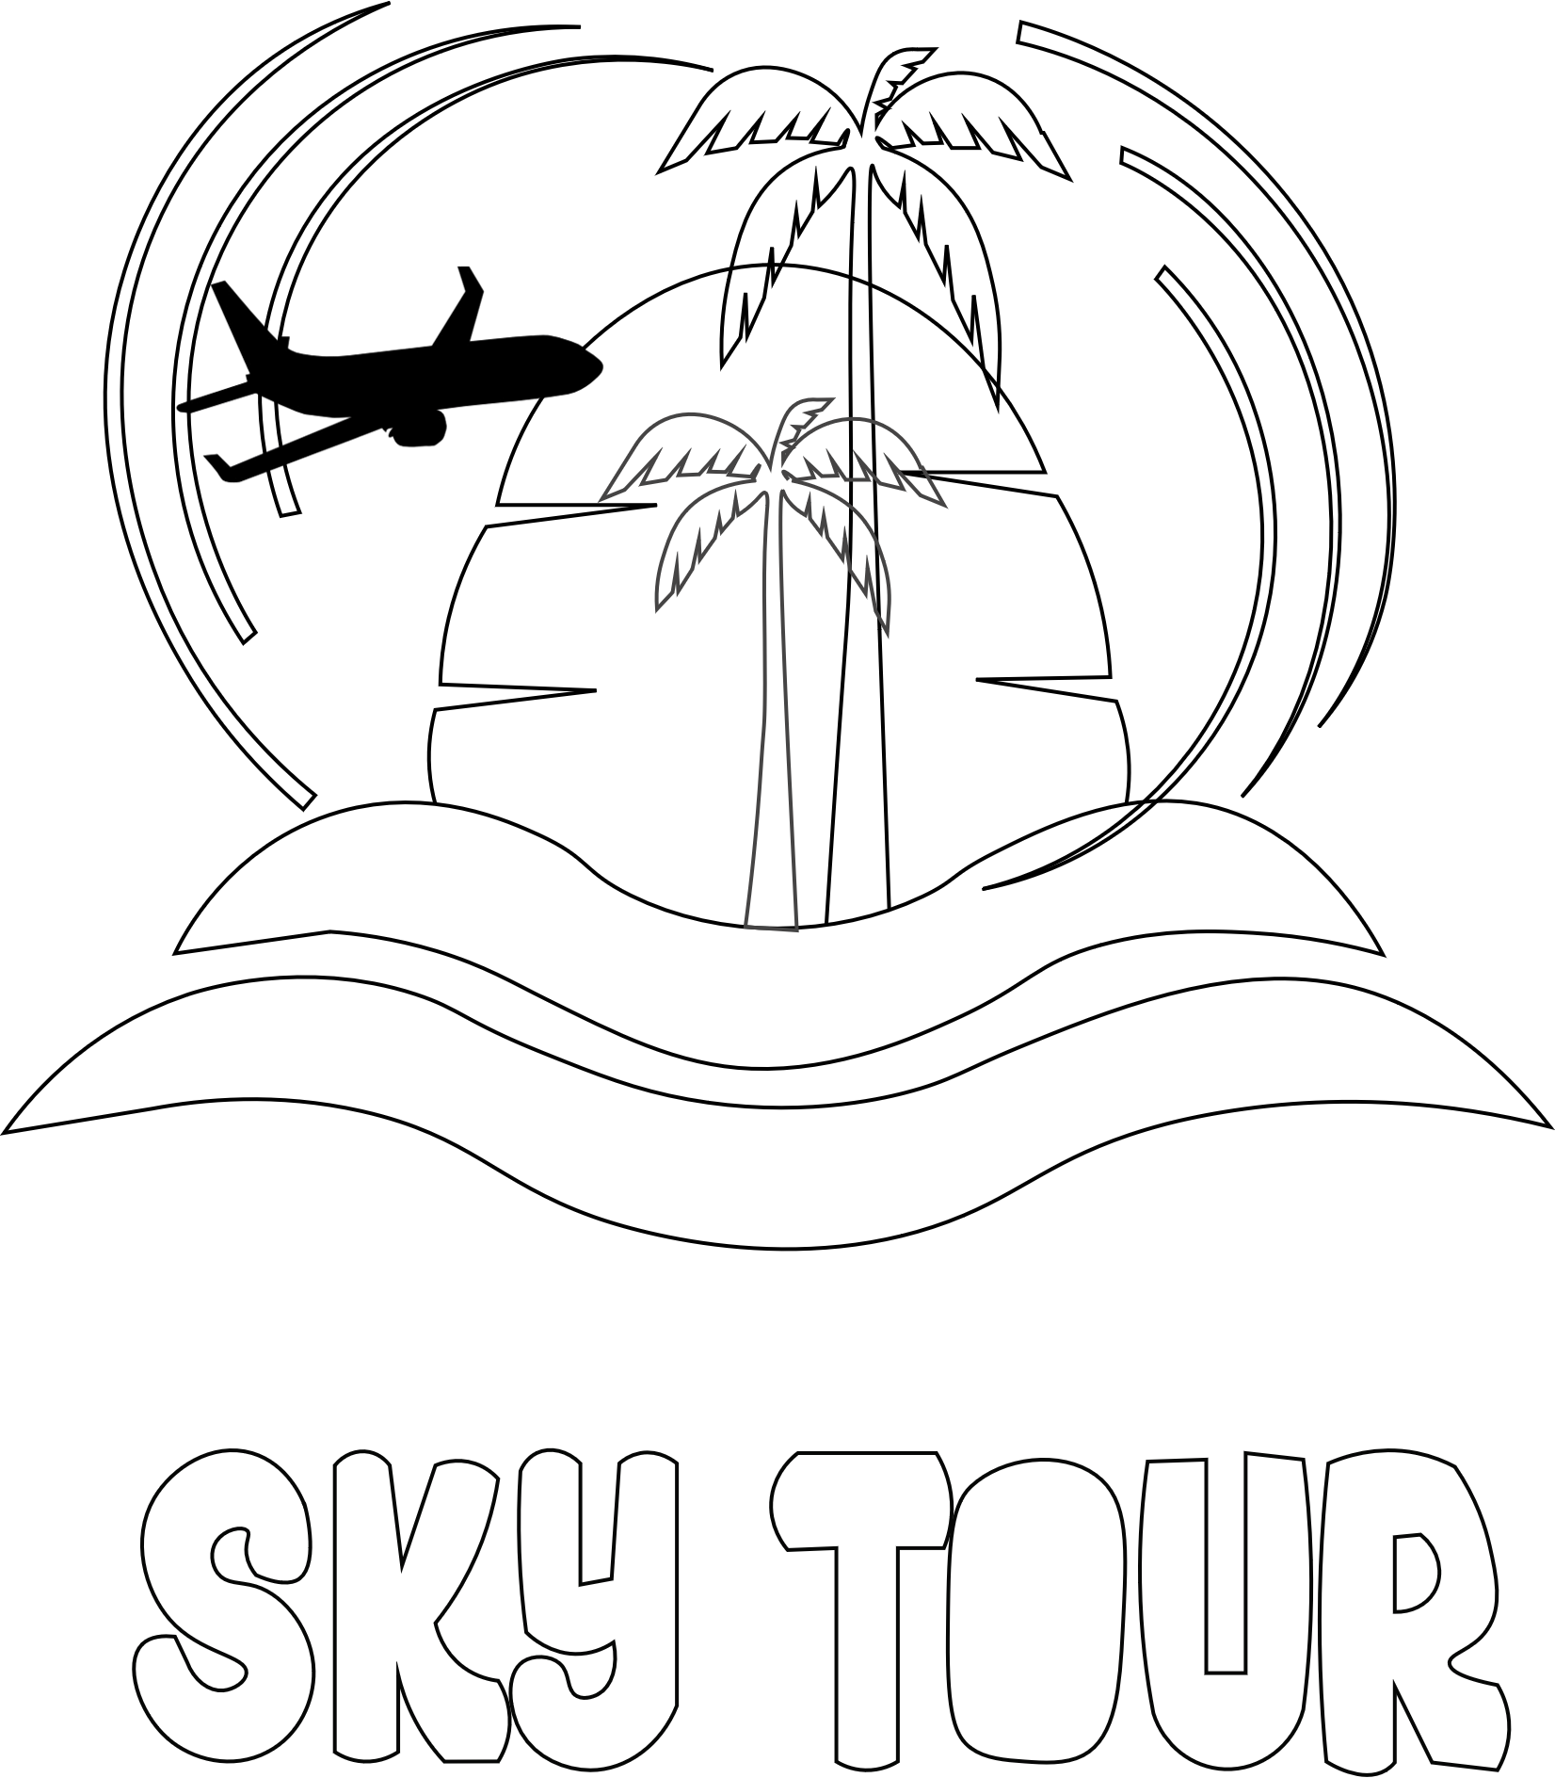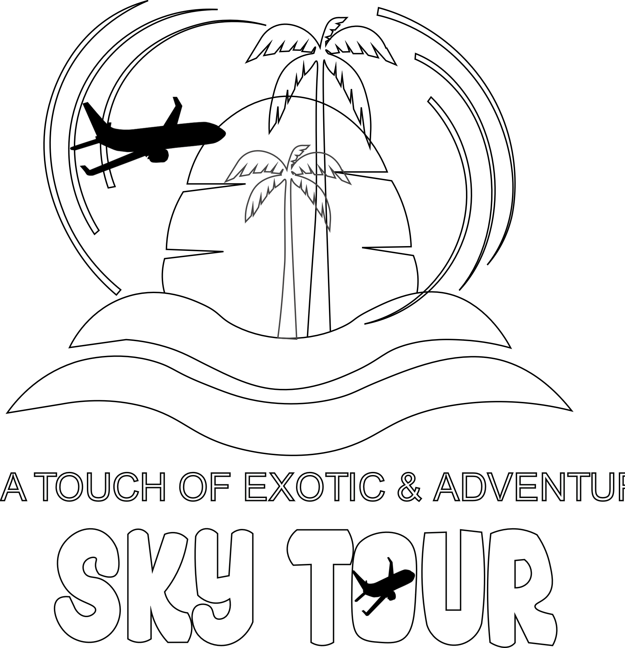



**T-SHIRT**

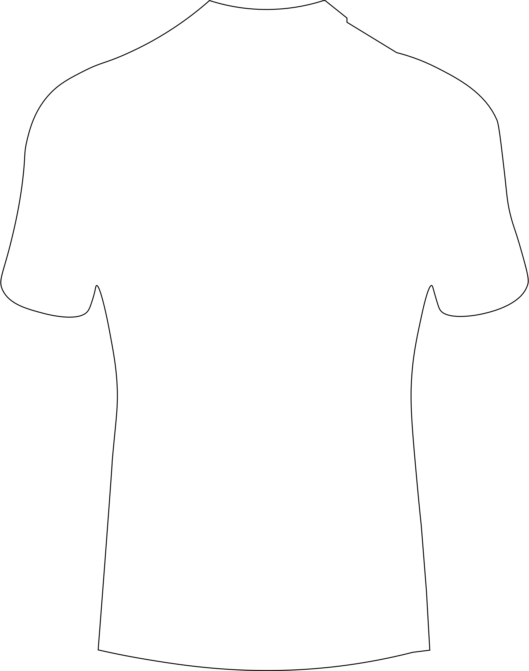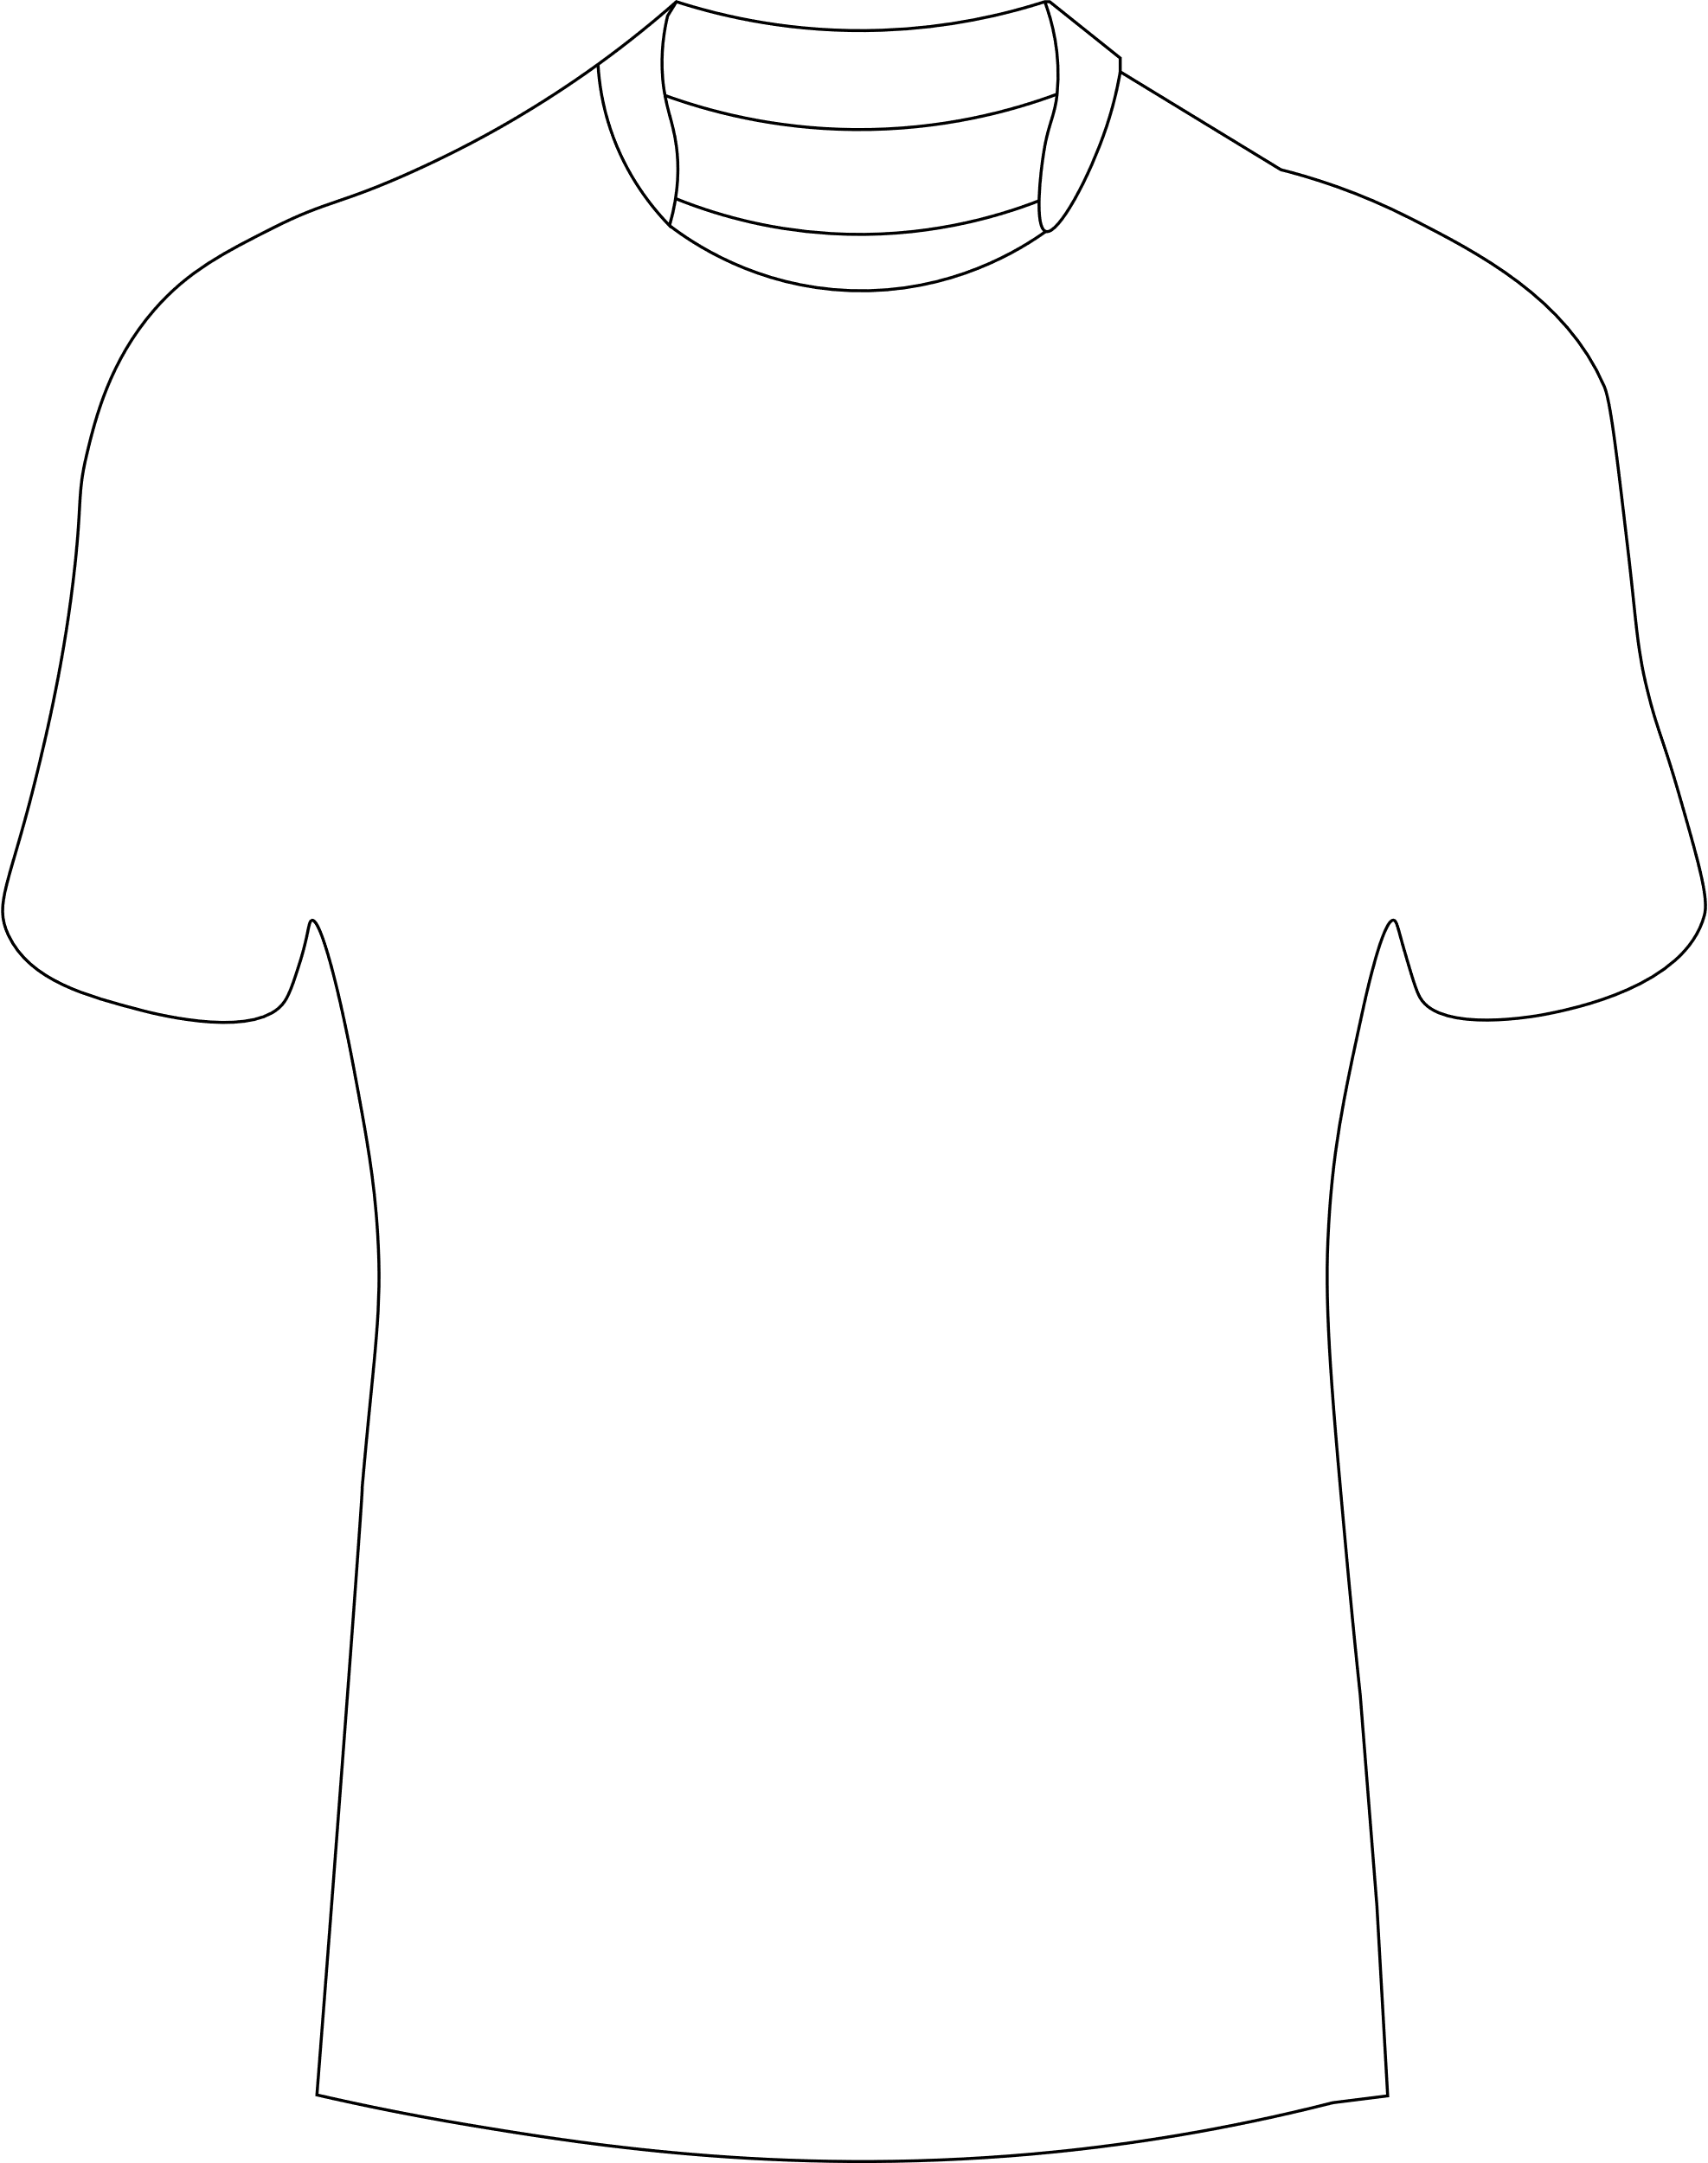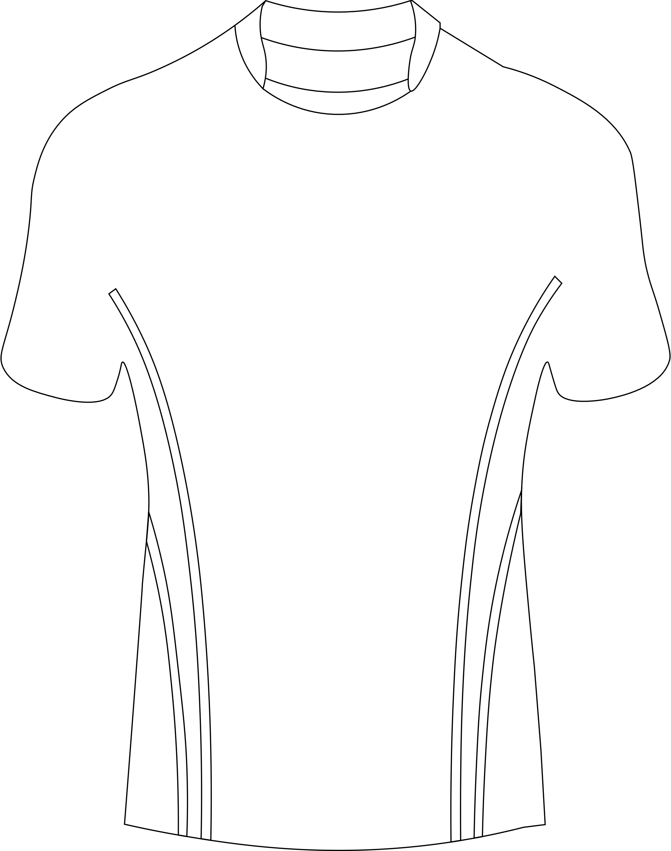



**CAP**

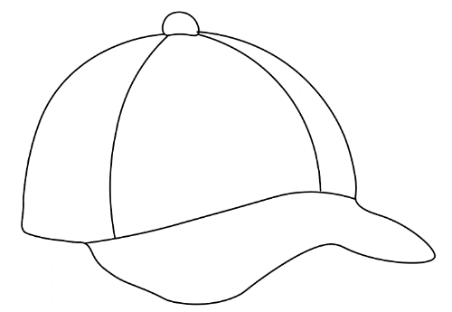 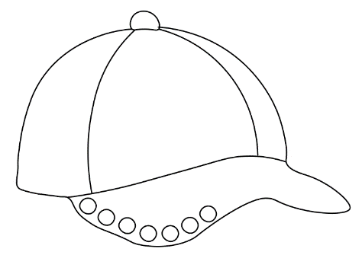 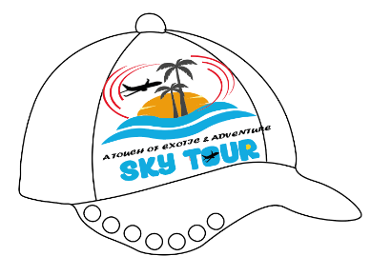

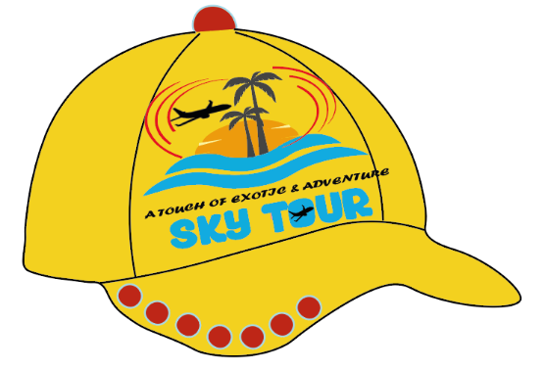

**BUSINESS CARD**

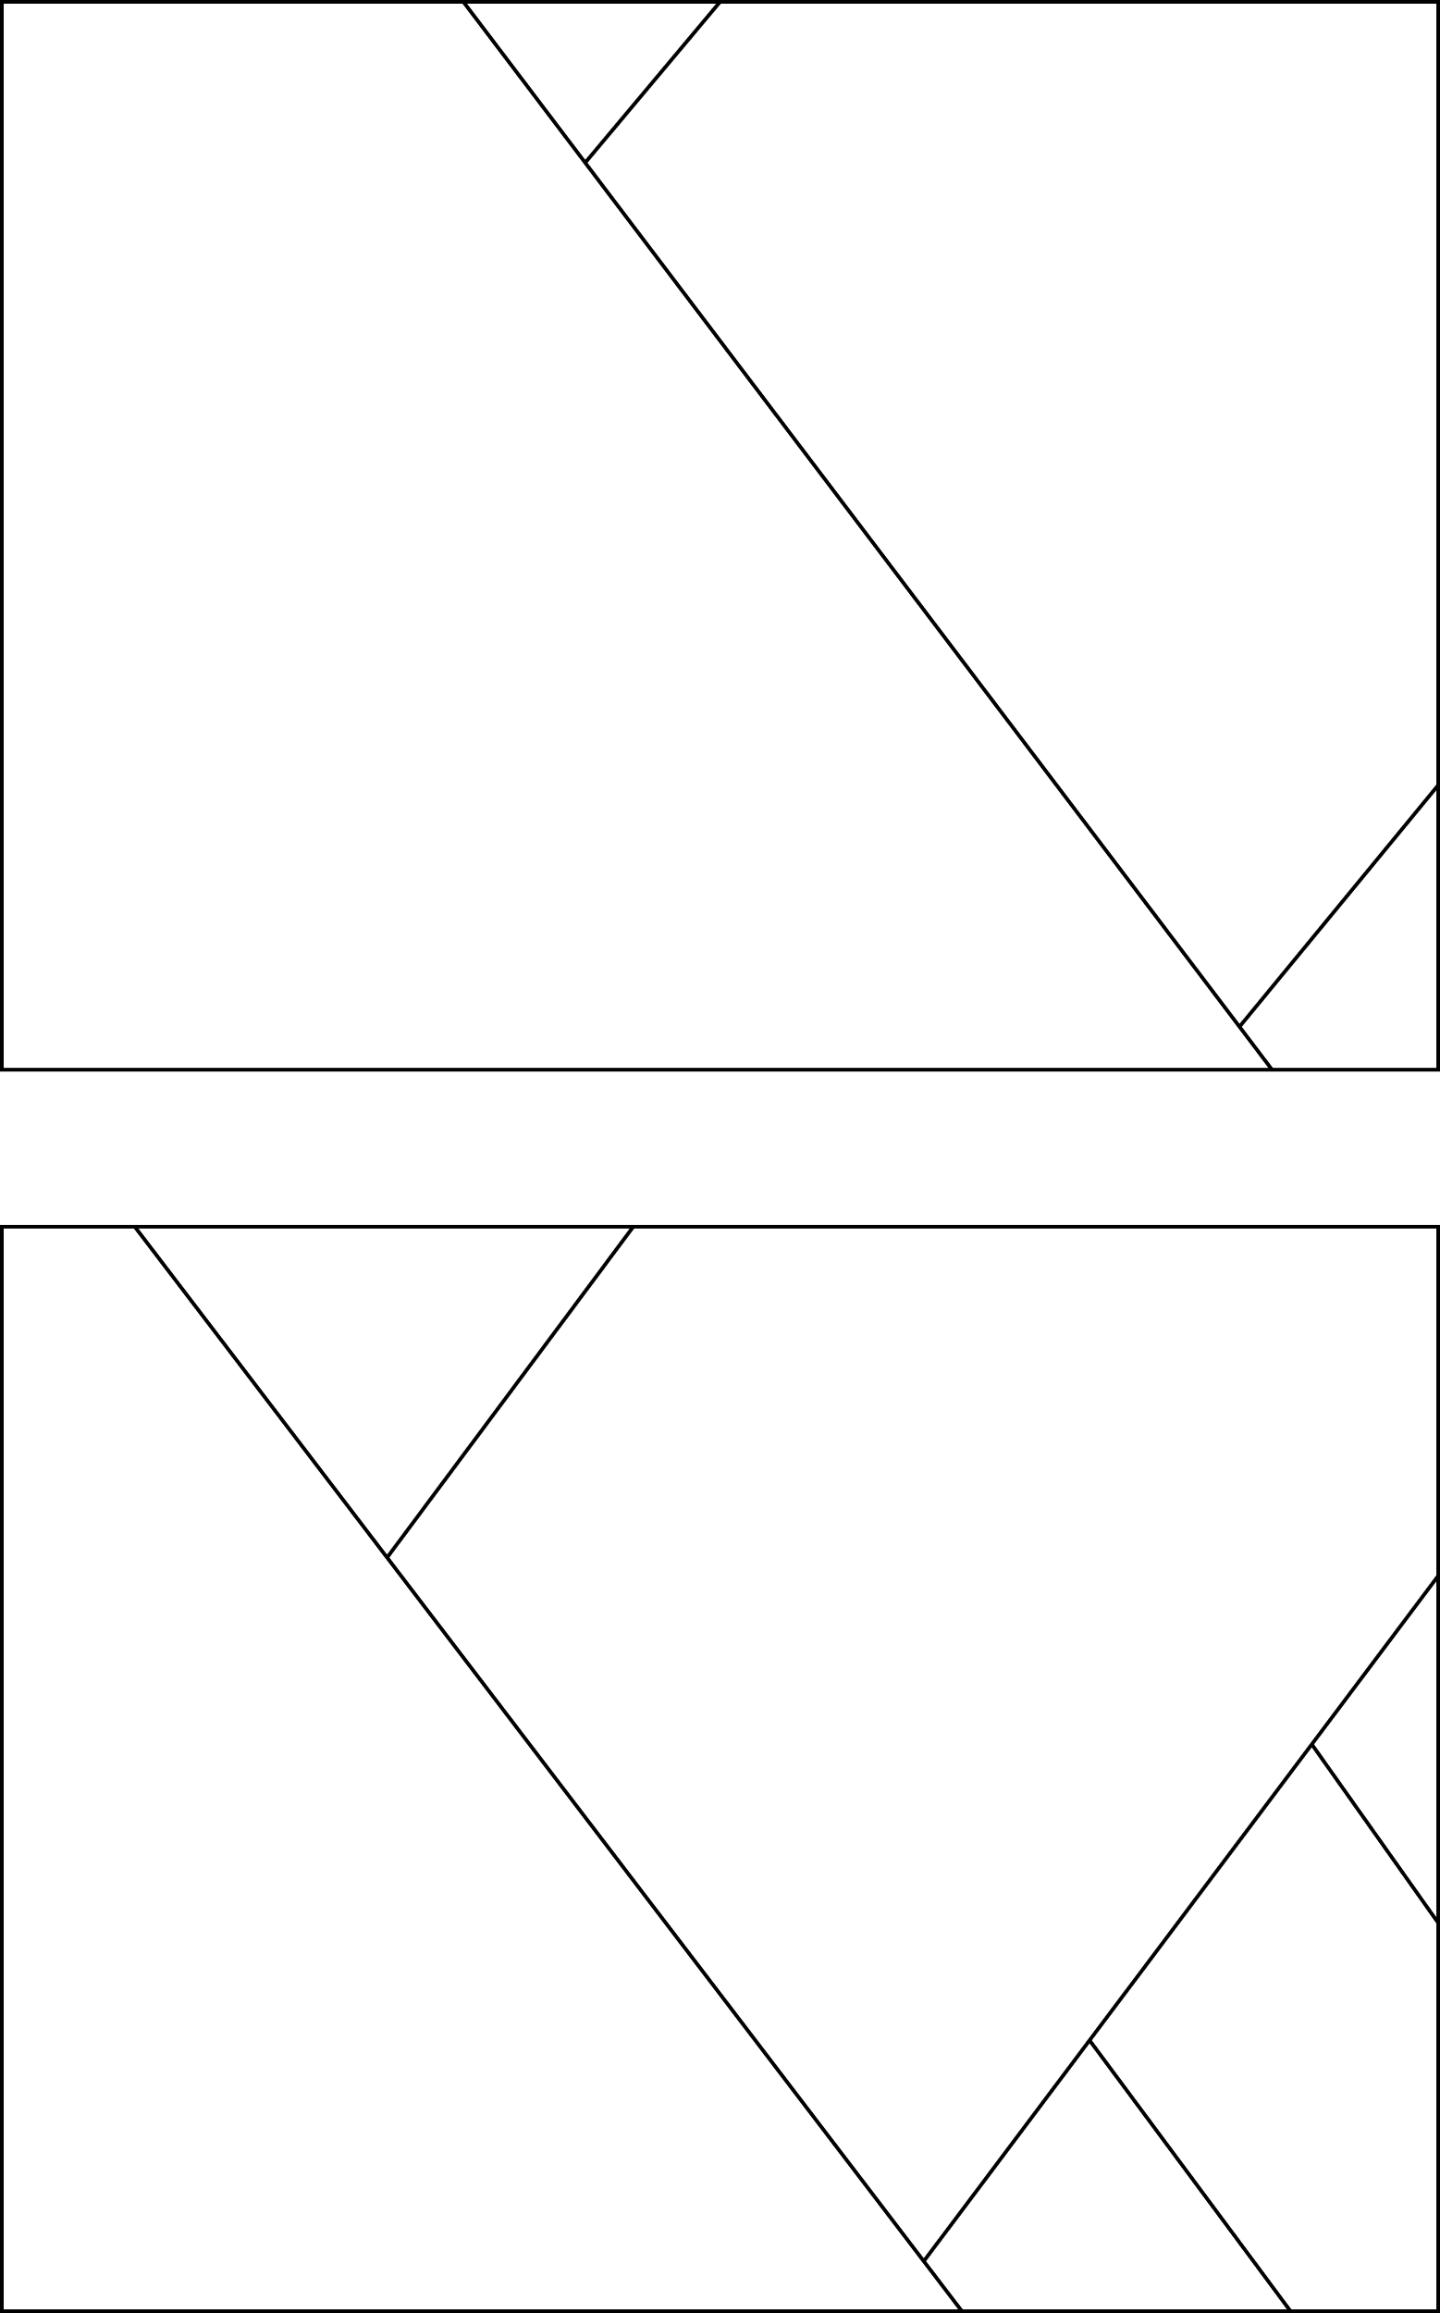 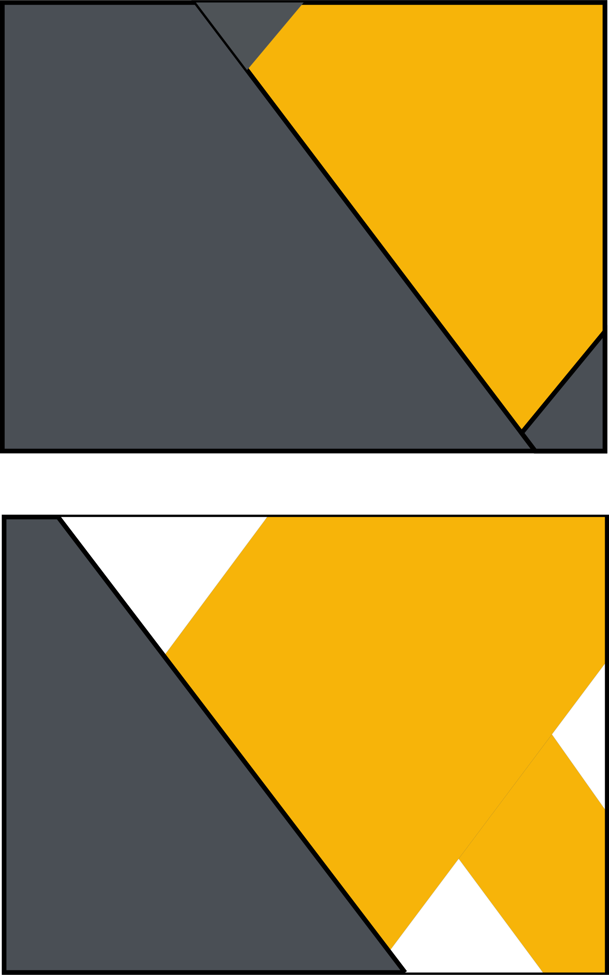 

**POSTER**

 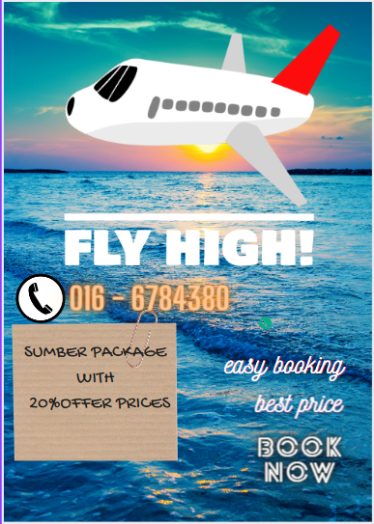 

**TYPOGRAPHY**

For this part of the typography, several types of writing have been referenced. This is to ensure that the writing used is appropriate.

Here are some types of writing that have been selected to be placed in the company name:

Sky tour

Sky tour

Sky tour

Finally chosen this font was chosen.



I also make some changes in the letter ‘O’ to make a little bit different from other companies. This is to ensure; our customers can identify Sky Tour company without logo and can guess what type of service will be. Therefore, the ‘O’ letter having flight design to give clear picture to customers, that this is a flight booking company.